**Gradients on a curved graph**

Plot each of these graphs and use a tangent to estimate the gradient for the stated x-value. Choose your own scales to use (1 square = 0.5 might be good to use on the x-axis) and remember to pay attention to them when finding the gradient!

a) y = x2 Find the gradient where x = 2

b) y = x2 + 2 Find the gradient where x = 2

c) y = x2 – 5x Find the gradient where x = 3

d) y = x3 Find the gradient where x = 1

e) y = x3 + x2 Find the gradient where x = -1

f) y = x3 – 4x2 + 8x Find the gradient where x = 2

g) Show on each of your graphs any locations where the gradient is 0.

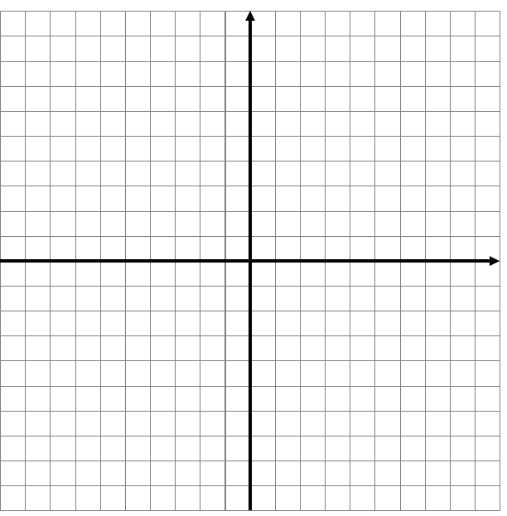

a)



b)

c)



d)

e)

f)

g) How do you know where the gradient is 0 on a graph?

______________________________________________________________________________________________________________________________________________________________________________________________________________________________________________________________________________________________________________________________________________________________________________________________________________________________________________________________________________________________________________________________________________________________________________________________________________

**Gradients on a curved graph ANSWERS**

Plot each of these graphs and use a tangent to estimate the gradient for the stated x-value. Choose your own scales to use (1 square = 0.5 might be good to use on the x-axis) and remember to pay attention to them when finding the gradient!

a) y = x2 Find the gradient where x = 2

🡪 4 🡪 Gradient of 0 at (0,0)

b) y = x2 + 2 Find the gradient where x = 2

🡪 4 🡪 Gradient of 0 at (0,2)

c) y = x2 – 5x Find the gradient where x = 3

🡪 6 🡪 Gradient of 0 at (2.5,-6.25)

d) y = x3 Find the gradient where x = 1

🡪 1 🡪 Gradient of 0 at (0,0)

e) y = x3 + x2 Find the gradient where x = -1

🡪 2 🡪 Gradient of 0 at (0,0) and (-2/3,4/27)

f) y = x3 – 4x2 + 8x Find the gradient where x = 2

🡪 4 🡪 No gradient of 0 anywhere!

g) Show on each of your graphs any locations where the gradient is 0.

Be lenient with accuracy on these!!!